Task – 22/09/2020

**Task 1: Component Interaction using @input (parent to child)**

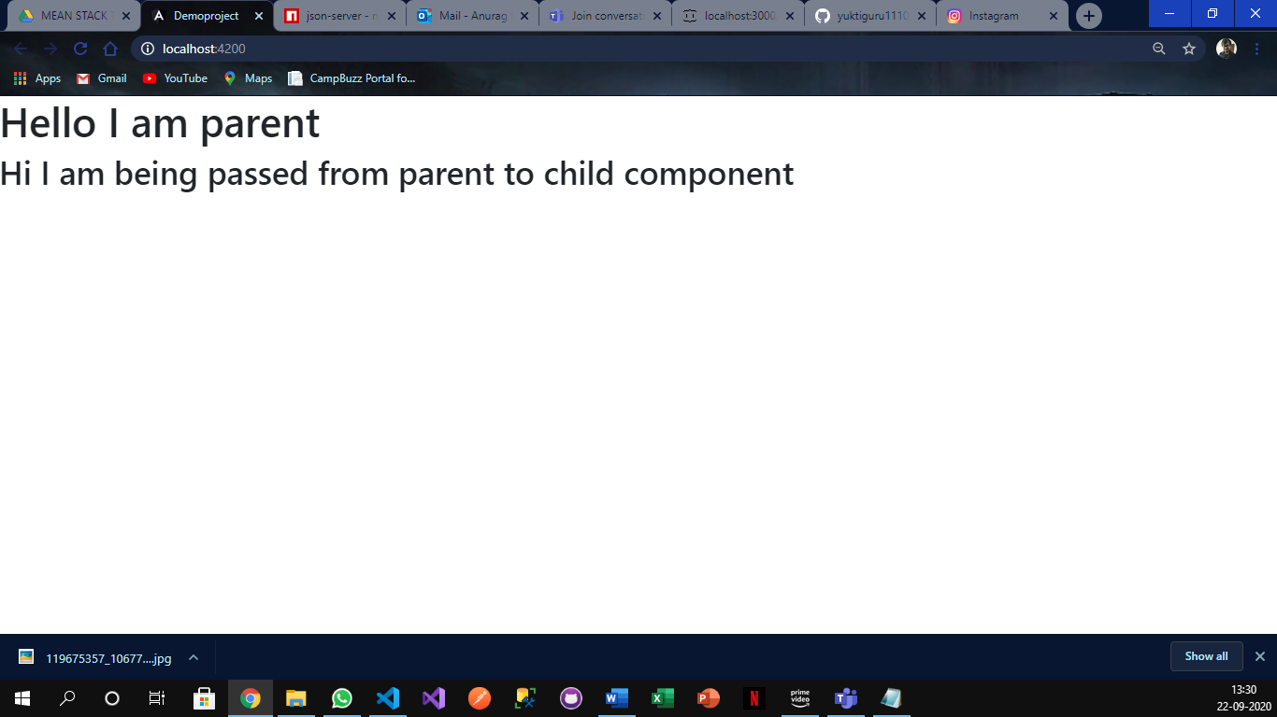

app.component.ts  
------------------------------------------------------------------------------------------------------------------------------------------

import { Component, OnInit } from '@angular/core';

@Component({

  selector: 'app-root',

  templateUrl: './app.component.html',

  styleUrls: ['./app.component.css']

})

export class AppComponent implements OnInit {

  message:string = "I am parent";

  childmessage:string = "I am being passed from parent to child component";

  ngOnInit(){

  }

}

------------------------------------------------------------------------------------------------------------------------------------------

app.component.html  
------------------------------------------------------------------------------------------------------------------------------------------

<h1>Hello {{message}}</h1>

<app-app-child [greetMessage] = "childmessage"></app-app-child>

------------------------------------------------------------------------------------------------------------------------------------------

app-child.component.ts  
------------------------------------------------------------------------------------------------------------------------------------------

import { Component, Input, OnInit } from '@angular/core';

@Component({

  selector: 'app-app-child',

  templateUrl: './app-child.component.html',

  styleUrls: ['./app-child.component.css']

})

export class AppChildComponent implements OnInit {

  @Input() greetMessage:string;

  constructor() { }

  ngOnInit(): void {

  }

}

------------------------------------------------------------------------------------------------------------------------------------------

app-child.component.html  
------------------------------------------------------------------------------------------------------------------------------------------

<h2>Hi {{greetMessage}}</h2>

------------------------------------------------------------------------------------------------------------------------------------------

**Task 2: Component Interaction using @input and @Output (2-way interaction ) using eventemitter**

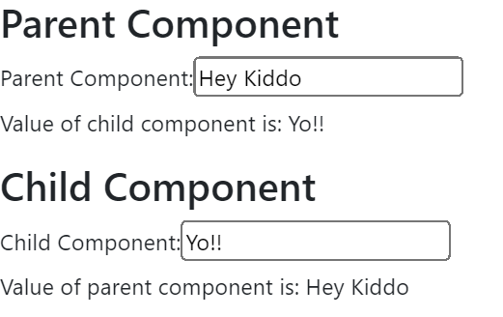

app.component.html  
------------------------------------------------------------------------------------------------------------------------------------------

<app-app-parent></app-app-parent>

<router-outlet></router-outlet>

------------------------------------------------------------------------------------------------------------------------------------------

app-parent.component.ts  
------------------------------------------------------------------------------------------------------------------------------------------

import { Component, OnInit } from '@angular/core';

@Component({

  selector: 'app-app-parent',

  templateUrl: './app-parent.component.html',

  styleUrls: ['./app-parent.component.css']

})

export class AppParentComponent implements OnInit {

  public CData:number;

  constructor() { }

  ngOnInit(): void {

  }

}

------------------------------------------------------------------------------------------------------------------------------------------

app-parent.component.html  
------------------------------------------------------------------------------------------------------------------------------------------

<h3>Parent Component</h3>

<label>Parent Component:</label>

<input type="text" #pcomponent (keyup)="0"/>

<p>Value of child component is: {{CData}}</p>

<app-app-child [PData]="pcomponent.value" (childEvent)="CData=$event"></app-app-child>

------------------------------------------------------------------------------------------------------------------------------------------

app-child.component.ts  
------------------------------------------------------------------------------------------------------------------------------------------

import { Component, EventEmitter, Input, Output, OnInit } from '@angular/core';

@Component({

  selector: 'app-app-child',

  templateUrl: './app-child.component.html',

  styleUrls: ['./app-child.component.css']

})

export class AppChildComponent implements OnInit {

  @Input() PData:number;

  @Output() childEvent = new EventEmitter();

  constructor() { }

  onChange(value){ this.childEvent.emit(value); }

  ngOnInit(): void {

  }

}

------------------------------------------------------------------------------------------------------------------------------------------

app-child.component.html  
------------------------------------------------------------------------------------------------------------------------------------------

<h3>Child Component</h3>

<label>Child Component:</label>

<input type="text" #ccomponent (keyup)="onChange(ccomponent.value)"/>

<p>Value of parent component is: {{PData}}</p>

------------------------------------------------------------------------------------------------------------------------------------------

**Task 3: Angular material practicals**

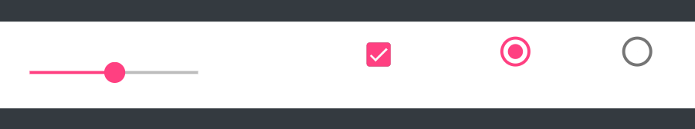

app.module.ts  
------------------------------------------------------------------------------------------------------------------------------------------

import { BrowserModule } from '@angular/platform-browser';

import { NgModule } from '@angular/core';

import { HttpClientModule } from '@angular/common/http';

import { CryptoService } from './crypto.service';

import { AppRoutingModule } from './app-routing.module';

import { AppComponent } from './app.component';

import { AppChildComponent } from './app-child/app-child.component';

import { AppParentComponent } from './app-parent/app-parent.component';

import { BrowserAnimationsModule } from '@angular/platform-browser/animations';

import { MaterialModule } from './shared/material.module';

import { MatSliderModule } from '@angular/material/slider';

import { CommonModule } from '@angular/common';

import { MatButtonModule  } from '@angular/material/button';

import { MatCheckboxModule } from '@angular/material/checkbox';

import { MatRadioModule } from '@angular/material/radio';

@NgModule({

  declarations: [

    AppComponent,

    AppChildComponent,

    AppParentComponent

  ],

  imports: [

    BrowserModule,

    AppRoutingModule,

    HttpClientModule,

    BrowserAnimationsModule,

    MaterialModule,

    MatSliderModule,

    MatRadioModule,

    CommonModule,

    MatButtonModule,

    MatCheckboxModule

  ],

  providers: [CryptoService],

  bootstrap: [AppComponent]

})

export class AppModule { }

------------------------------------------------------------------------------------------------------------------------------------------

material.module.ts  
------------------------------------------------------------------------------------------------------------------------------------------

import { NgModule } from '@angular/core';

import { CommonModule } from '@angular/common';

import { MatButtonModule  } from '@angular/material/button';

import { MatCheckboxModule } from '@angular/material/checkbox';

import { MatRadioModule } from '@angular/material/radio';

@NgModule({

  declarations: [],

  imports: [

    CommonModule,

    MatButtonModule,

    MatCheckboxModule,

    MatRadioModule

  ],

  exports:[

    MatButtonModule,

    MatCheckboxModule,

    MatRadioModule

  ]

})

export class MaterialModule { }

------------------------------------------------------------------------------------------------------------------------------------------

app.component.ts  
------------------------------------------------------------------------------------------------------------------------------------------

import { Component, OnInit } from '@angular/core';

@Component({

  selector: 'app-root',

  templateUrl: './app.component.html',

  styleUrls: ['./app.component.css']

})

export class AppComponent implements OnInit {

  ngOnInit(){

  }

}

------------------------------------------------------------------------------------------------------------------------------------------

app.component.html  
------------------------------------------------------------------------------------------------------------------------------------------

<div class="p-3 mb-2 bg-dark text-white">

  <div class="d-flex justify-content-center bg-white " style="padding-top: 10px">

    <mat-slider min="1" max="100" step="1" value="1"></mat-slider>

    <button mat-button> Click Here!!</button> <mat-checkbox> Check Me!</mat-checkbox>

    <mat-radio-group>

      <mat-radio-button value="1">Option 1</mat-radio-button>

      <mat-radio-button value="2">Option 2</mat-radio-button>

    </mat-radio-group>

  </div>

</div>

------------------------------------------------------------------------------------------------------------------------------------------